SQL Module Assessment
Business Workforce Analytics | Module 2
Duration: 60 minutes | Maximum Marks: 100 | Database: Data_Analytics_HR

Q1 — Find the Right Employees — 20 marks

Create SQL queries to:
• show employees earning ₹70,000 or more, highest salary first;
Query:
Select emp_name, salary from employees where salary <= 70000 order by salary desc;
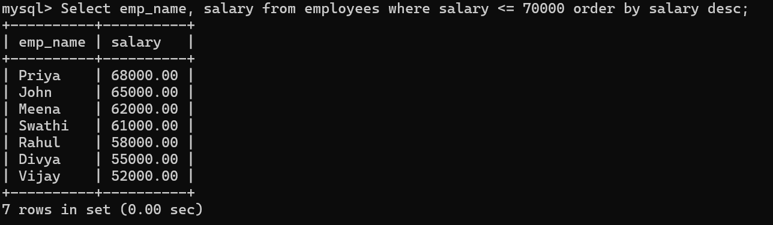

• identify employees from Department IDs 1 or 3 whose role contains “Analyst”;
Query:
Select emp_name, dept_id, job_role from employees where dept_id in (1,3) and job_role like ‘%Analyst%’;

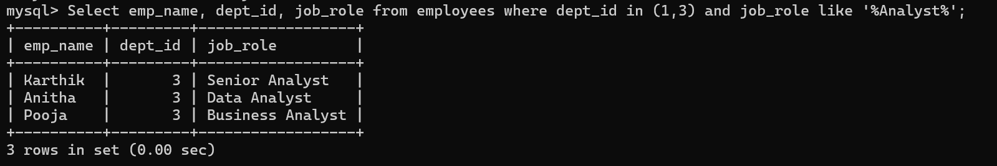
• show the three highest-paid employees.
Query:
Select emp_name, salary from employees order by salary desc limit 3;
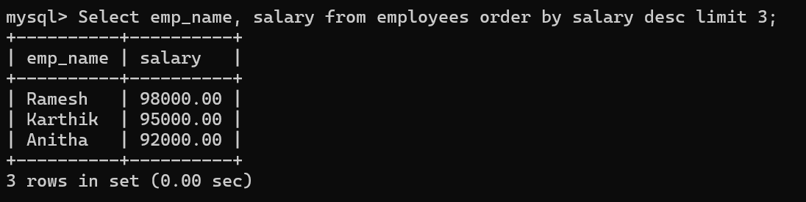

Q2 — Understand the Workforce — 25 marks
Create a department-level summary showing headcount, average salary and total payroll. Show only departments with at least 2 employees.
Query:
Select dept_id,
count(*) as headcount,
avg(salary) as avg_salary,
sum(salary) as total_payroll
from employees
group by dept_id
having count(*) > = 2; 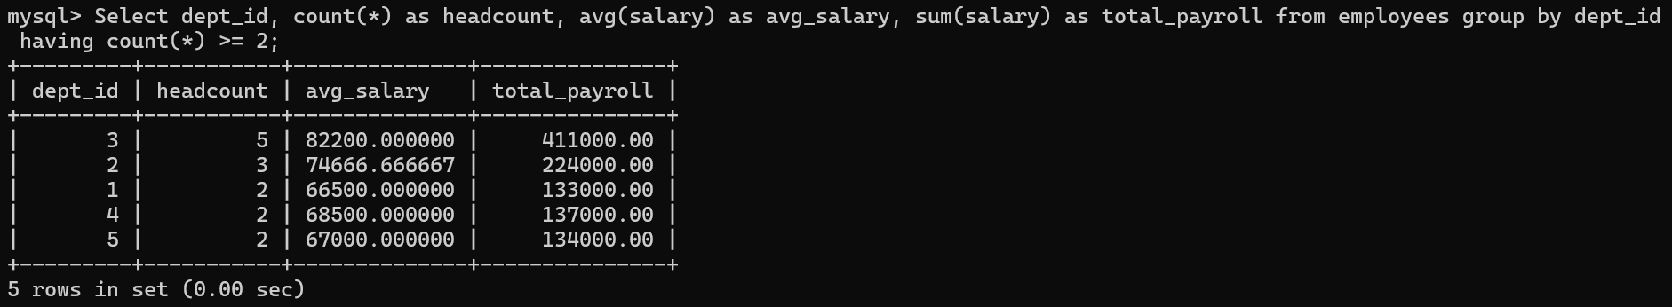

Also classify employees as:
• High — ₹90,000 or above
• Medium — ₹60,000 to ₹89,999
• Entry — below ₹60,000.
Query:
Select emp_name, salary, case when salary < 60000 then ‘Entry’ when salary >=60000 and salary <89999 then ‘Medium else ‘high’ end as ‘category’ from employees;
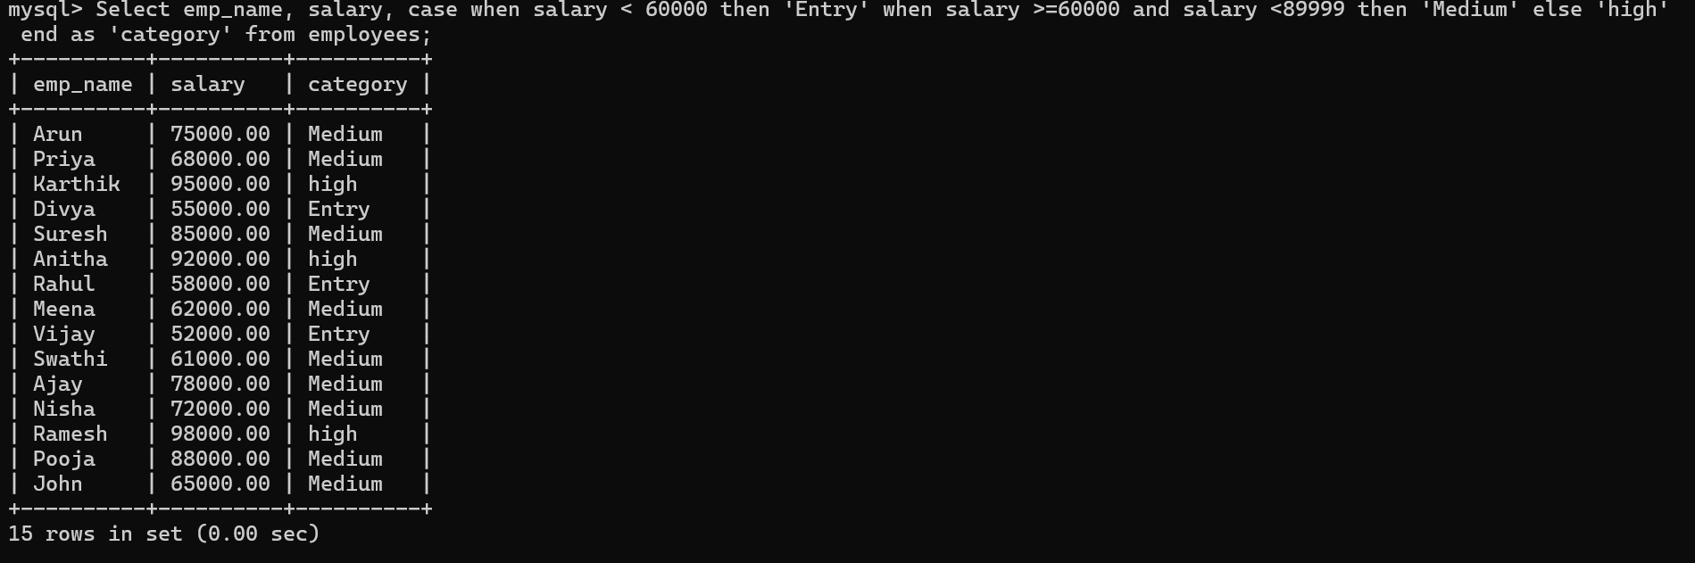

Q3 — Connect & Investigate — 25 marks

Connect Employees and Departments to show Employee Name, Job Role, Department Name and Branch Location.
Then:
• show department-wise headcount and average salary, retaining departments even if no employees exist;

Query;
Select d.dept_id, d.dept_name, count(e.emp_id) as headcount, avg(e.salary) as average_salary from departments d inner join employees e on d.dept_id=e.dept_id group by d.dept_id, d.dept_name;
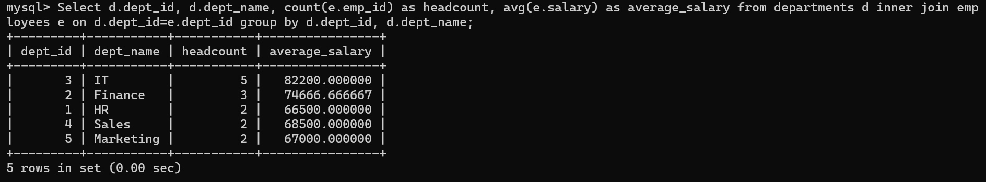

• identify employees earning above the overall company average
Query:
Select emp_name from employees where salary > (select avg(salary) from employees);
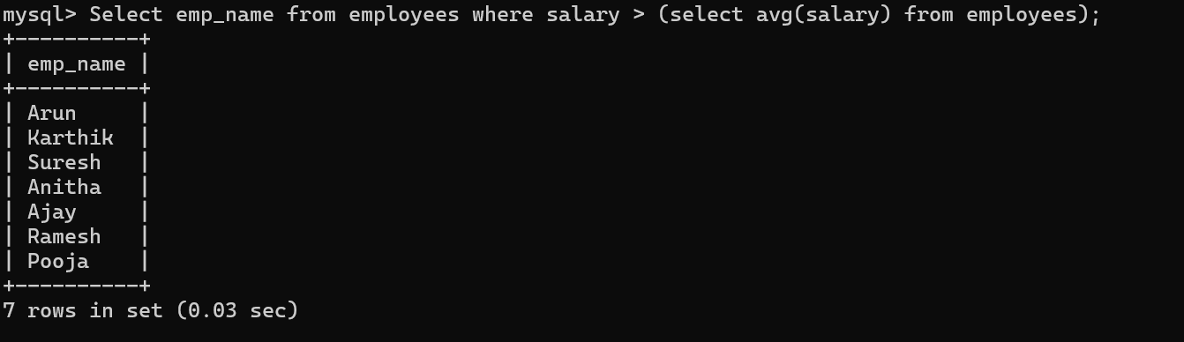
• calculate department payroll and return departments whose payroll is above ₹150,000.
Query:
Select d.dept_id, d.dept_name, sum(e.salary) as dept_payroll from departments d inner join employees e on d.dept_id=e.dept_id group by d.dept_id, d.dept_name having sum(e.salary) > 150000;
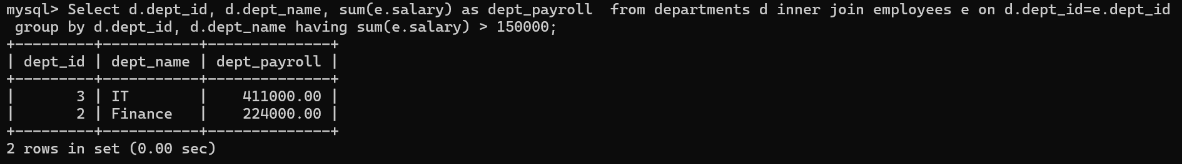

Q4 — Validate & Recommend — 30 marks
Check the data for:
• employees with missing email addresses
Query:
Select * from employees where email_id is null;


• Employee Department IDs with no matching Department record. If no rows are returned, explain what that means.
Query:
Select e.emp_id, e.emp_name, d.dept_id from employees e left join departments d on e.dept_id =d.dept_id where d.dept_id is null;


